FOOL’S GARDEN -LEMON TREE
Fill in the blanks with The Simple Present Tense & Simple Present Continuous Tense

I ____ (sit) here in the boring room
It ___ (be) just another rainy Sunday afternoon
I ______(waste) my time
I got nothing to do
I _______ (hang) around
I _____(wait) for you
But nothing ever happens and I wonder
I _____ (drive) around in my car
I _____ (drive) too fast
I _____ (drive) too far
I'd like to change my point of view
I _____ (feel) so lonely
I_____ (wait) for you
But nothing ever happens and I wonder
I wonder how
I wonder why
Yesterday you told me 'bout the blue blue sky
And all that I can see is just a yellow lemon-tree
I _____ (turn) my head up and down
I_____ (turn) around
And all that I can see is just another lemon-tree
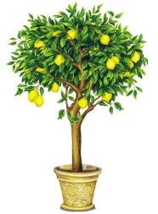
I ______(sit) here
I miss the power
I'd like to go out taking a shower
But there's a heavy cloud inside my head
I feel so tired
Put myself into bed
Well, nothing ever happens and I wonder
Isolation ___ (be) not good for me
Isolation I don't want to sit on the lemon-tree
I____ (step) around in the desert of joy
Baby anyhow I'll get another toy
And everything will happen and you wonder

